RFarm

(Remote Farming Application)

## A MINI PROJECT REPORT FOR THE COURSE

**DESIGN THINKING**

***Submitted by***

|  |  |
| --- | --- |
| **THARUN RAJ I** | **230701362** |
| **SREYA G** | **230701334** |
| **VERONICA REGINA PAUL** | **230701377** |

***In partial fulfillment for the award of the degree of***

**BACHELOR OF ENGINEERING**

**IN**

**COMPUTER SCIENCE AND ENGINEERING**

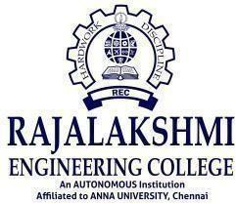

**RAJALAKSHMI ENGINEERING COLLEGE (AUTONOMOUS) THANDALAM**

**CHENNAI - 602105**

**2024 - 25**

**BONAFIDE CERTIFICATE**

Certified that this Thesis titled “**RFarm – Remote Farming Application**” is the Bonafide work of **THARUN RAJ I (230701362), SREYA G (230701334),**

**VERONICA REGINA PAUL (230701377)** who carried out the work under my supervision. Certified further that to the best of my knowledge the work reported herein does not form part of any other thesis or dissertation on the basis of which a degree or award was conferred on an earlier occasion on this or any other candidate.

Dr. KUMAR.P Dr. G.DHARANI DEVI

Head of Department Associate Professor

Computer Science and Engineering Computer Science and Engineering

Rajalakshmi Engineering College Rajalakshmi Engineering College

Submitted to Project Viva Voce Examination held on _________________________

Signature Examiner – 1 Signature Examiner – 2

ii

**TABLE OF CONTENTS**

**CHAPTER NO. TITLE PAGE NO.**

|  |  |  |
| --- | --- | --- |
| 1 | **ABSTRACT**  **LIST OF FIGURES INTRODUCTION** | vi  viii  1 |
|  | 1.1 Design Thinking Approach | 1 |
|  | 1.2 Stanford Design Thinking Model  and its Phases | 3 |
| 2 | **LITERATURE REVIEW** | 5 |
|  | 2.1 IoT in Smart Agriculture | 5 |
|  | 2.2 Sensor – Based Irrigation Systems | 5 |
|  | 2.3 Use of MERN Stack and Embedded  Systems | 6 |
|  | 2.4 Application of Design Thinking in  Agricultural Tech | 7 |
|  | 2.5 Summary of Gaps Identified | 7 |
| 3 | **DOMAIN AREA** | 8 |
|  | 3.1 Overview of Smart Agriculture | 8 |
|  | 3.2 Relevance of IoT in Agriculture | 9 |
|  | 3.3 Problem Statement Addressed | 10 |
|  | 3.4 Scope of the Project | 10 |
| 4 | **EMPATHIZE STAGE** | 11 |
|  | 4.1 Activities Conducted | 12 |
|  | 4.2 Secondary Research | 12 |
|  | 4.3 Primary Research & Insights | 13 |
|  | 4.4 Identified User Needs | 14 |
| 5 | **DEFINE STAGE** | 15 |
|  | 5.1 Analysis of User Needs | 15 |
|  | 5.2 Brainstorming to Frame Problem  Statements | 16 |
|  | 5.3 Final Selected Problem Statement | 17 |
|  | iii |  |

|  |  |  |
| --- | --- | --- |
| **CHAPTER NO.**  6 | **TITLE**  **IDEATION STAGE** | **PAGE NO.**  18 |
|  | 6.1 Analysis of the Problem Statement | 19 |
|  | 6.2 Mind Mapping | 19 |
|  | 6.3 Brainstorming Session Results | 20 |
|  | 6.4 Final Solution Selected | 21 |
|  | 6.5 Value Proposition Statement | 22 |
| 7 | **PROTOTYPE STAGE** | 23 |
|  | 7.1 Hardware Components | 23 |
|  | 7.2 Software Stack | 25 |
|  | 7.3 Features of the Prototype | 28 |
| 8 | **TEST AND FEEDBACK** | 29 |
|  | 8.1 Feedback from Team Members | 29 |
|  | 8.2 Feedback from Peer Reviewers (Other  Teams) | 30 |
|  | 8.3 Feedback from Users (Farmers and  Consultants) | 31 |
| 9 | **RE-DESIGN AND IMPLEMENTATION** | 32 |
|  | 9.1 Improvements Based on Technical  Feedback | 32 |
|  | 9.2 Enhancements from UI/UX Feedback | 33 |
|  | 9.3 Feature Additions from End-User  Suggestions | 34 |
|  | 9.4 Hardware Deployment and  Implementation | 35 |
| 10 | **CONCLUSION** | 36 |
| 11 | **FUTURE WORK** | 38 |
|  | 11.1 Integration of AI and Data Analytics | 38 |
|  | 11.2 Mobile Application Development | 39 |
|  | 11.3 Extended Sensor Network | 40 |
|  | 11.4 Solar-Based Power Optimization | 40 |
|  | 11.5 Government and Institutional  Collaborations | 40 |
| 12 | **LEARNING OUTCOME OF DESIGN THINKING** | 41 |
|  | 12.1 Key learnings from Each Stage | 42 |
|  | iv |  |

## CHAPTER NO. TITLE PAGE NO.

12.2 Broader Impact and Growth 44

13 **REFERENCES** 45

# **ABSTRACT**

Agriculture remains the foundation of human sustenance, yet modern-day farming faces significant challenges such as inefficient irrigation, unpredictable rainfall, and the absence of real-time data, all of which contribute to reduced productivity and unnecessary resource wastage. Traditional irrigation systems are often static and require manual intervention, making them ineffective for addressing the dynamic needs of location-diverse farmlands.

This project, titled **"RFarm – A remote farming application"**, introduces a robust IoT-based solution that allows farmers to remotely monitor and control irrigation across multiple fields situated in different geographical locations. The system integrates ultrasonic sensors for paddy field water level detection, moisture sensors for general crop monitoring, and a rain sensor to assess real-time precipitation. These sensors are connected via a Wi-Fi-enabled microcontroller that transmits environmental data using HTTP protocols.

The system is developed using the **MERN stack (MongoDB, Express.js, React.js, Node.js)** for the web interface, and **Embedded C** for sensor-level programming. Through real-time data analysis, farmers receive actionable insights such as soil moisture levels, water level alerts, and rainfall predictions. Additionally, the platform

incorporates weather forecasting and seasonal crop recommendations tailored to regional climate and soil data.

By automating irrigation decisions and integrating smart data analytics, this solution reduces water usage, improves crop yield, and supports the adoption of sustainable and precision agriculture practices. It empowers farmers with the flexibility to manage and optimize irrigation processes from any location, ensuring improved productivity and resource efficiency in modern agriculture.

**LIST OF FIGURES**

|  |  |  |
| --- | --- | --- |
| **FIGURE NO.** | **TITLE** | **PAGE NO.** |
| Fig no. 1 | Stanford Design Thinking  Process | 2 |
| Fig no. 2 | Empathy Map for Farmers | 15 |
| Fig no. 3 | User Persona for RFarm | 18 |
| Fig no. 4 | Mind Map of RFarm  Features | 20 |
| Fig no. 5 | Customer Journey Map | 22 |
| Fig no. 6 | Circuit Design of RFarm  using IoT Components | 24 |
| Fig no. 7 | Home page of RFarm site | 26 |
| Fig no. 8 | Signup page of RFarm | 26 |
| Fig no. 9 | Login page of RFarm | 26 |
| Fig no. 10 | Fields page of RFarm | 26 |
| Fig no. 11 | Field details page(Mobile view) | 27 |
| Fig no. 12 | Anomaly detection mail | 27 |
| Fig no. 13 | Field details page  (Desktop view) | 27 |

Fig no. 14 Applicaton of Design thinking 44  
 process in RFarm

viii

# **INTRODUCTION**

## Design Thinking Approach

Design Thinking is a user-centric and iterative methodology focused on understanding real-world problems through empathy and collaboration, followed by the creative development of innovative and feasible solutions. In the context of smart agriculture, Design Thinking ensures that the solutions address actual challenges faced by farmers, such as limited accessibility to resources, inefficient irrigation methods, and lack of real-time data insights.

Design Thinking fosters creative problem-solving by emphasizing direct engagement with users (farmers, agronomists), defining clear problem statements based on field research, and generating ideas that are repeatedly tested and refined through feedback. By applying this approach to agricultural innovation, the team ensures that the final solution is not only technically viable but also practical and meaningful for end users.

## Types of Design Thinking Models

Several models of Design Thinking have been developed to cater to different contexts. Some of the most recognized ones include:

## Stanford d.school Model

* Empathize
* Define
* Ideate
* Prototype
* Test

This five-phase model is widely adopted for innovation across industries and forms the core of our project methodology.

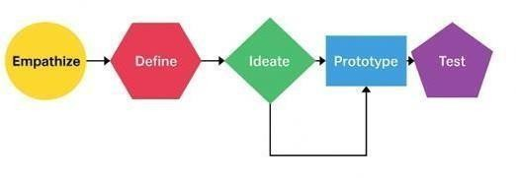

**Fig no. 1 – Stanford Design Thinking Process Flow**

## IDEO Human-Centered Design Model

* Inspiration
* Ideation
* Implementation

This model is particularly useful for projects in the social and environmental domains.

1. **Double Diamond Model** (British Design Council)

* Discover
* Define
* Develop
* Deliver

It emphasizes the divergence and convergence of ideas at every phase.

## IBM Design Thinking

* Focuses on collaboration, agile iteration, and scalable systems for large enterprises using AI and data-driven insights.

For our IoT-based Agriculture Irrigation System, the **Stanford d.school Model** was selected due to its strong user-empathy foundation and structured, iterative development process.

## 1.2 Stanford Design Thinking Model and Its Phases

The Stanford Design Thinking model consists of five distinct, interconnected stages. Each stage is essential in shaping solutions that are innovative, user-focused, and adaptable.

## Empathize

This phase involves deeply understanding the challenges of end users—in this case, farmers. Through surveys, interviews, and field visits, we gathered insights into the limitations of current irrigation practices, their dependency on weather patterns, and the lack of digital tools in resource management.

## Define

All the user insights collected during the empathize phase are synthesized to form a clear, actionable problem statement. This problem definition guides all subsequent design and development efforts.

## Ideate

Creative brainstorming sessions are conducted to generate a wide range of possible solutions. Mind mapping, group discussions, and user feedback help filter the ideas into the most practical and innovative ones.

## Prototype

In this phase, scaled-down versions of the solution are developed. For this project, an IoT-based prototype with sensor integration and a web-based dashboard was built to test functionality and usability.

## Test

The prototype is deployed in a real or simulated environment where users interact with it. Their feedback is analyzed, and improvements are made in subsequent design iterations. This phase helps in refining the product to closely meet user needs.

* + 1. **LITERATURE REVIEW**

## IoT in Smart Agriculture

Recent studies show that Internet of Things (IoT) technology plays a transformative role in agriculture by enabling real-time monitoring, data collection, and automation. According to Gupta et al. (2022), the integration of IoT sensors in farming has resulted in improved water management, reduced manual effort, and better crop health through data-driven decisions.

IoT systems commonly involve soil moisture sensors, temperature and humidity sensors, ultrasonic level sensors for water levels, and weather stations. Data from these devices is transmitted to a cloud server or a web-based application, which helps farmers make timely and accurate irrigation decisions.

## Sensor-Based Irrigation Systems

A study by Patel and Sinha (2021) demonstrated the effectiveness of moisture- sensor-based automated irrigation, which helped reduce water usage by up to 35% compared to traditional timed irrigation. Their research emphasized the importance of sensor calibration and real-time feedback in managing field irrigation, especially in water-scarce regions.

Another research by Zhao et al. (2020) integrated rainfall and ultrasonic sensors into an automated irrigation controller for rice fields. It concluded that adaptive irrigation using real-time environmental data significantly boosted productivity while preventing waterlogging and crop stress.

## Use of MERN Stack and Embedded Systems

In web-based agricultural applications, the MERN (MongoDB, Express, React, Node.js) stack has emerged as a reliable and scalable choice for real-time dashboards. Studies by Jain et al. (2023) show that MERN-based systems offer enhanced user interfaces for farmers, allowing easier interpretation of sensor data and control of irrigation systems remotely.

Simultaneously, microcontrollers like NodeMCU or ESP32 are often programmed in Embedded C to capture sensor data efficiently and transmit it via Wi-Fi. Research by Kumar and Rao (2021) supports the use of Wi-Fi-enabled microcontrollers due

to their low power consumption, real-time communication capabilities, and cost- effectiveness.

## Application of Design Thinking in Agricultural Tech

Design Thinking has increasingly been used in agricultural tech development. A report by the World Bank Innovation Lab (2020) highlighted how involving farmers in the ideation and testing process resulted in more widely adopted technology solutions. Prototypes built with constant user feedback led to better acceptance and real-world utility.

In particular, the Stanford d.school model has proven effective in developing location-specific solutions that consider factors such as crop type, water availability, and climate variability.

## Summary of Gaps Identified

* + - * + Traditional irrigation systems still rely on manual observation and are inefficient.
        + Existing smart systems often lack integration with multi-sensor data and weather forecasting.
        + There is limited user-focused design in current agricultural IoT applications.
        + Real-time remote access and multi-field management features are missing in most current models.

This project aims to bridge these gaps through a holistic, design-thinking-based approach that leverages both IoT and full-stack web technologies to empower farmers.

# **DOMAIN AREA**

Smart Agriculture, driven by IoT (Internet of Things) technologies, represents a shift from traditional agricultural practices to precision farming. The domain leverages interconnected devices, sensors, and cloud platforms to enhance agricultural productivity, sustainability, and resource efficiency.

## Overview of Smart Agriculture

Smart agriculture utilizes embedded systems, environmental sensors, wireless communication, and data analytics to monitor and manage farming activities in real time. It allows for automation of irrigation, fertilization, pest control, and crop monitoring based on data collected from the field.

Key components of smart agriculture include:

* + - * + **Sensor Technologies**: Soil moisture, temperature, humidity, rain detection, and ultrasonic water level sensors.
        + **Wireless Communication**: Use of Wi-Fi-enabled microcontrollers for remote data transmission.
        + **Web/Mobile Interfaces**: Dashboards for visualizing real-time data and controlling irrigation systems.
        + **Data Analytics**: Processing historical and real-time data for decision-making and predictive insights.
        + **Automation**: Activating irrigation pumps or valves automatically based on sensor inputs and predefined logic.

## Relevance of IoT in Agriculture

The increasing unpredictability of weather conditions and growing water scarcity demand intelligent solutions. IoT enables farmers to:

* + - * + **Monitor soil and environmental parameters in real time.**
        + **Automate irrigation schedules based on sensor thresholds.**
        + **Reduce water and electricity usage.**
        + **Prevent under- or over-irrigation.**
        + **Receive weather forecasts and crop recommendations.**

By collecting and analyzing data, farmers can make informed decisions, increase yield, and reduce operational costs.

## Problem Statement Addressed

In India and other agricultural economies, farmers often manage multiple geographically distributed fields. Manual inspection and irrigation across locations are time-consuming and inefficient. Additionally, most irrigation is based on fixed schedules rather than actual soil or weather conditions, leading to water wastage and crop stress.

Our IoT-based **Agriculture Irrigation System** addresses these issues by:

* + - * + Enabling **remote monitoring** and **automated irrigation control**.
        + Providing **field-specific environmental insights**.
        + Integrating **multi-sensor data** with **weather-based decision logic**.
        + Delivering a **user-friendly dashboard** for anytime, anywhere access.

## Scope of the Project

This project focuses on:

* + - * + Monitoring **moisture levels**, **paddy field water levels**, and **rainfall** using sensors.
        + Processing sensor data through a **NodeMCU/ESP32 microcontroller**.
        + Sending data to a cloud database via **HTTP**.
        + Displaying data and control options via a **web dashboard** built with the

## MERN stack.

* + - * + Recommending **seasonal crops** based on weather and soil data.
        + Supporting **multiple fields** in different locations from a single platform.

The system is designed with scalability and modularity in mind, making it adaptable for small farms as well as large-scale agricultural operations.

# **EMPATHIZE STAGE**

The **Empathize stage** is the first and most crucial phase in the Design Thinking process. In this phase, we focus on understanding the needs, challenges, and pain points of the end users—in our case, **farmers.** By engaging directly with users and analyzing their routines, we gain deep insights that guide the entire product development cycle.

## Activities Conducted

To understand the real-world problems faced by farmers, the following user research activities were conducted:

* + - * + **Interviews**: We interacted with farmers managing paddy fields, vegetable farms, and fruit orchards to learn about their irrigation methods, schedules, and challenges.
        + **Field Visits**: We visited agricultural fields in both rural and semi-urban areas to observe manual irrigation setups and usage patterns.
        + **Questionnaires**: Surveys were distributed among a small group of farmers and agricultural students to collect structured feedback on current irrigation practices and openness to technology adoption.

## Secondary Research

Secondary research involved reviewing:

* + - * + Government agriculture reports and policies on water use and crop planning.
        + Academic papers on IoT-based irrigation systems.
        + Online forums and blogs where farmers discussed their daily challenges.
        + Case studies from smart farming startups and agri-tech companies.

Key findings:

* + - * + **Over 65% of farmers still rely on manual irrigation** based on guesswork or visual soil inspection.
        + **Unpredictable rainfall** often leads to overwatering or delayed irrigation.
        + **Lack of affordable technology** keeps many farmers from adopting smart systems.

## Primary Research & Insights

From our field interactions, we gathered the following key insights:

* + - * + **Moisture and rainfall detection** is critical. Farmers often water crops without knowing whether rain is imminent, leading to unnecessary usage.
        + Many farmers expressed a desire for a **mobile-accessible or online dashboard** to view irrigation data.
        + **Traveling between fields** located in different areas wastes time and labor.
        + There is growing awareness and acceptance of technology among younger farmers, especially those using smartphones and basic digital tools.

## Identified User Needs

Based on the primary and secondary research, we identified the following core user needs:

|  |  |
| --- | --- |
| **Need** | **Why It Matters** |
| Real-time soil and water level monitoring | Helps avoid guesswork and ensures timely irrigation. |
| Rain detection | Prevents unnecessary watering just before or during rainfall. |
| Multi-location support | Saves time and effort by enabling remote management of fields. |
| Automated decision-making | Reduces dependency on manual supervision. |
| Easy-to-use interface | Encourages adoption among non-tech-savvy  users. |
| Crop recommendations | Helps farmers choose the right crops based on seasonal and soil data. |

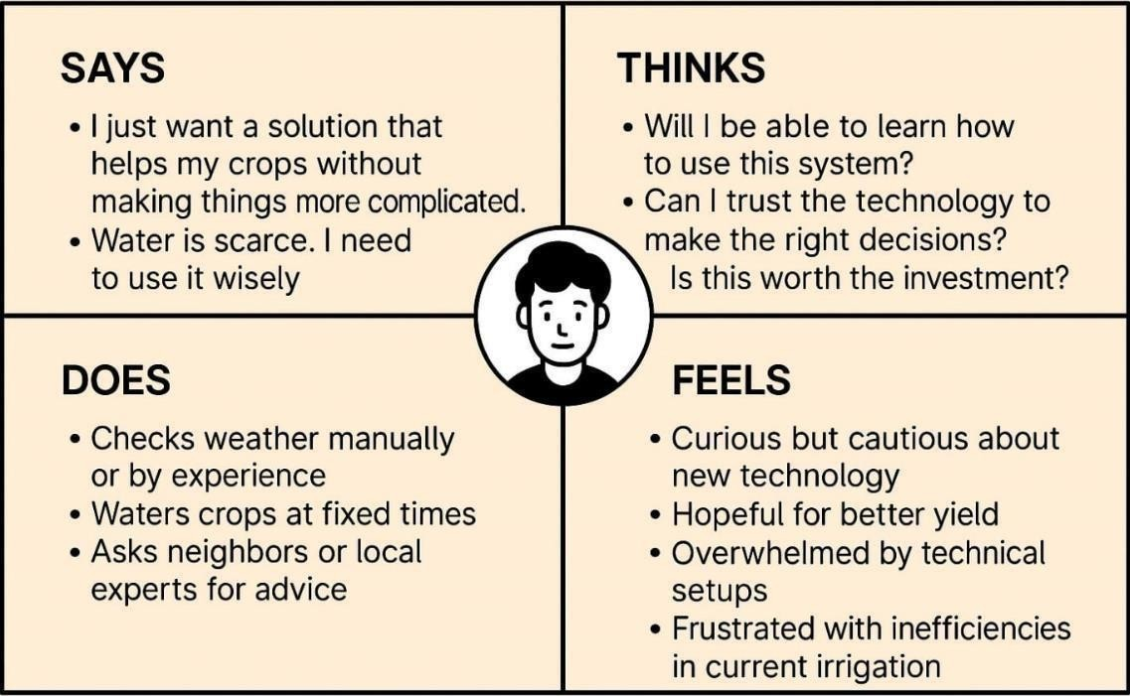

**Fig no. 2 – Empathy Map for Farmers**

# **5. DEFINE STAGE**

The **Define stage** focuses on synthesizing all the observations, feedback, and insights gathered during the Empathize phase into a focused and actionable **problem statement**. This ensures that our solution directly targets the users' real challenges.

## Analysis of User Needs

From the Empathize stage, several key themes emerged:

* + - Manual irrigation practices are **time-consuming and inefficient**.
    - Farmers need **remote access** to monitor multiple fields from anywhere.
    - There’s a lack of **data-driven decision-making tools** in small to mid-sized farms.
    - Irrigation often doesn’t consider **real-time rainfall** or **soil moisture**.
    - **User-friendly technology** is necessary for wider adoption among farmers.

## Brainstorming to Frame Problem Statements

We conducted multiple brainstorming sessions with our team, combining mind maps and "How Might We..." prompts to frame possible problem statements based on user needs.

Here are three potential problem statements we explored:

**Problem Statement 1**

"Farmers managing multiple fields often waste time and water due to the lack of real-time insights and automated irrigation systems. How might we create an affordable, IoT-based solution that helps them monitor and control irrigation remotely?"

**Problem Statement 2**

"Traditional irrigation is based on fixed schedules and assumptions, which leads to overwatering or underwatering. How might we use environmental data like moisture, water levels, and rainfall to automate intelligent irrigation?"

**Problem Statement 3**

"Farmers often struggle to determine the right crop for the current season and soil conditions. How might we integrate crop recommendations and weather forecasts into an easy-to-use irrigation system?"

## Final Selected Problem Statement

After evaluating feasibility, impact, and relevance to the IoT and MERN stack technologies we were using, we finalized the following:

## "Farmers managing geographically distributed fields often lack access to real- time soil and weather data, resulting in inefficient irrigation and resource wastage. How might we build an IoT-based irrigation system that enables remote monitoring, automated irrigation control, and field-specific insights through a user-friendly dashboard?"

This focused problem statement guided the **Ideation stage** where we explored and selected the best possible solution.

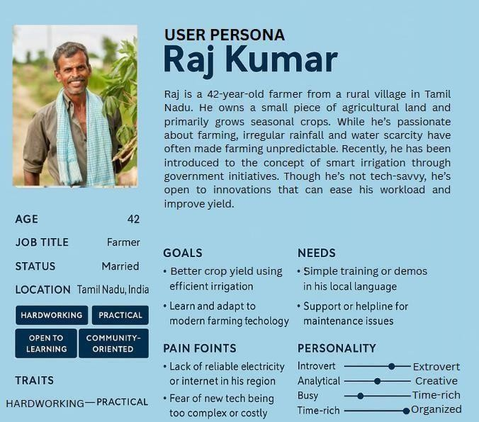

**Fig no. 3 – User Persona for RFarm**

# **IDEATION STAGE**

The **Ideation stage** is where creativity meets problem-solving. After clearly defining the users' needs and challenges, we began generating a wide range of ideas that could potentially solve the problem. The goal was to think beyond obvious solutions and explore innovative, practical, and scalable ideas that meet the user needs identified earlier.

## Analysis of the Problem Statement

“How might we build an IoT-based irrigation system that enables remote monitoring, automated irrigation control, and field-specific insights through a user-friendly dashboard?”

From this, we identified the key focus areas:

* + - Sensor-based data collection (moisture, water level, rain)
    - Real-time transmission and processing of data
    - Automation of irrigation logic
    - Remote accessibility via the web
    - Field-specific data views
    - Weather forecast and crop advisory

## Mind Mapping

We created a mind map to explore all potential solution areas:

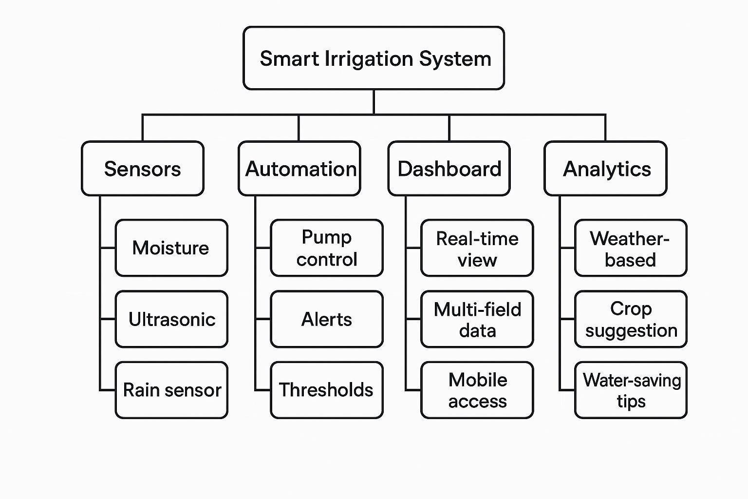

**Fig no. 4 – Mind Map for RFarm Features**

## Brainstorming Session Results

We identified **four promising ideas** during our brainstorming sessions:

## Idea 1: IoT-Based Auto-Irrigation System

A system using soil moisture sensors to automatically turn irrigation pumps on or off based on set thresholds.

## Idea 2: Multi-Field Remote Management Dashboard

A MERN-based web interface to monitor multiple farm locations, view sensor data, and manually override irrigation controls.

## Idea 3: Weather-Linked Smart Control

Integration with a weather API to pause or delay irrigation if rainfall is forecasted.

## Idea 4: Crop Planner & Recommendations

A module that analyzes seasonal and regional data to suggest the best crops for planting.

## Final Solution Selected

After evaluating feasibility, relevance to the user needs, and innovation, we chose to combine Ideas 1, 2, and 3 into a single solution:

**An IoT-based Smart Irrigation System** with sensor-driven automation, real-time data access through a web dashboard, and integration of weather-based decision logic.

This solution:

* + - Provides real-time sensor feedback
    - Supports remote control for multiple fields
    - Automates irrigation intelligently
    - Helps farmers conserve water and improve yield

## Value Proposition Statement

“Our IoT-based Smart Irrigation System empowers farmers to monitor and manage irrigation across multiple locations using real-time environmental data and a web- based dashboard. By automating irrigation based on sensor inputs and weather forecasts, it saves water, reduces manual effort, and enhances crop productivity—all through an intuitive and affordable platform.”

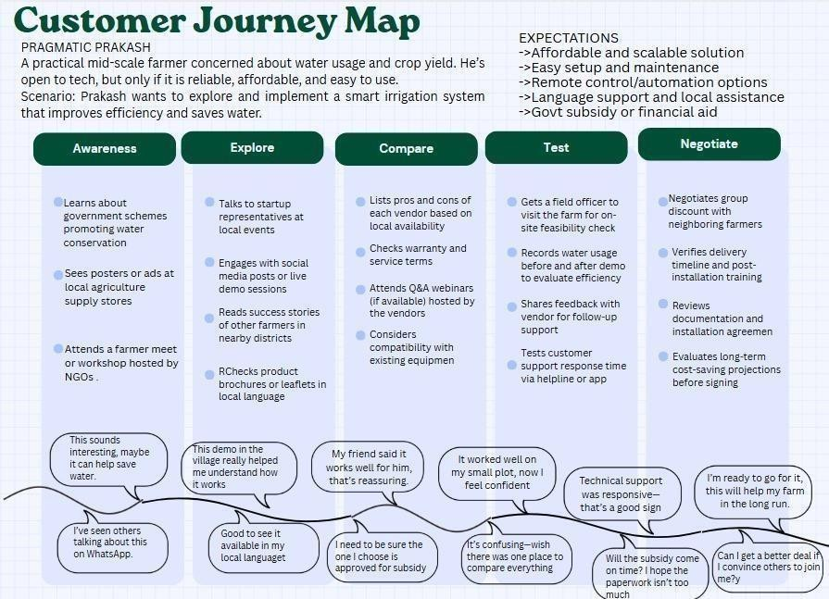

**Fig no. 5 - Customer Journey Map**

# **PROTOTYPE STAGE**

The **Prototype stage** focused on creating a functional model of the proposed **IoT- based Agriculture Irrigation System** using the ESP8266 microcontroller and essential sensors. The goal was to validate the technical feasibility and user interface for remote monitoring and smart irrigation control.

## Hardware Components

1. **ESP8266 (NodeMCU)**
   * Serves as the central microcontroller unit.
   * Connects to Wi-Fi and transmits sensor data via HTTP to the server.
   * Controls the relay module to automate irrigation.

## Soil Moisture Sensor

* + Measures the volumetric water content of the soil.
  + Helps determine whether irrigation is needed.

## Ultrasonic Sensor

* + Monitors the water level in paddy fields by measuring the distance from the sensor to the water surface.

## Rain Sensor

* + Detects rainfall intensity and prevents unnecessary watering when rain is detected.

## Relay Module

* + Connected to a water pump.
  + Operated based on moisture/rain data or user input from the dashboard.

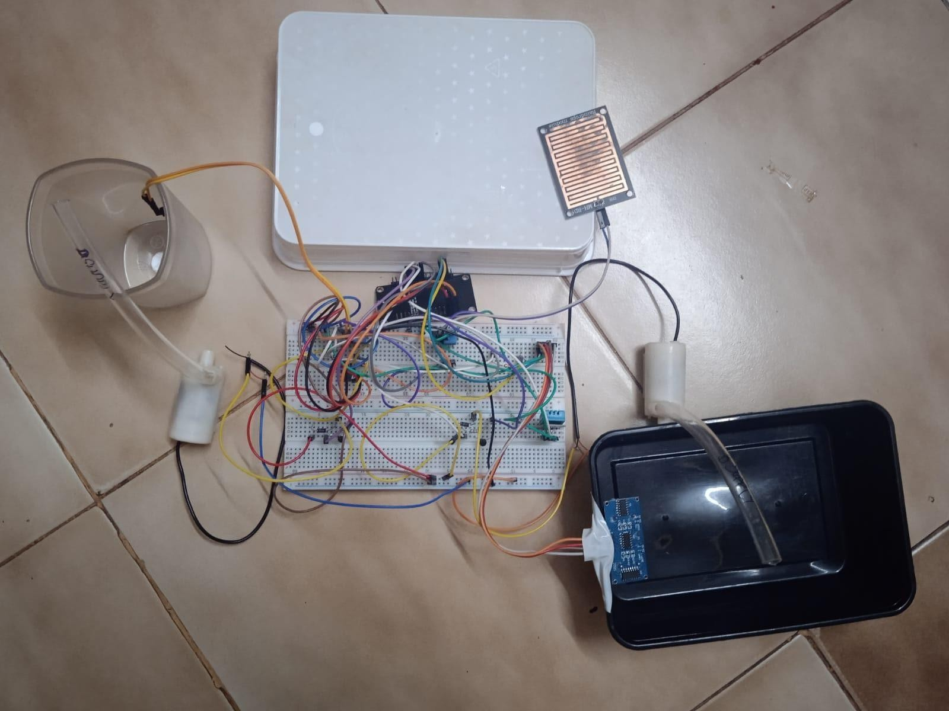

**Fig no. 6 - Circuit Design of RFarm using IoT Components**

## Software Stack

* + - **Embedded C (Arduino IDE)**
      * Programs the ESP8266 to read sensor data, process it, and send it to the web server using HTTP requests.

## MongoDB

* + - * Stores incoming sensor data and system logs.

## Express.js & Node.js (Backend)

* + - * Receives and processes requests from the ESP8266.
      * Hosts REST APIs for frontend interaction.

## React.js (Frontend)

* + - * Displays real-time sensor readings and weather information.
      * Allows farmers to view field status and toggle irrigation remotely.

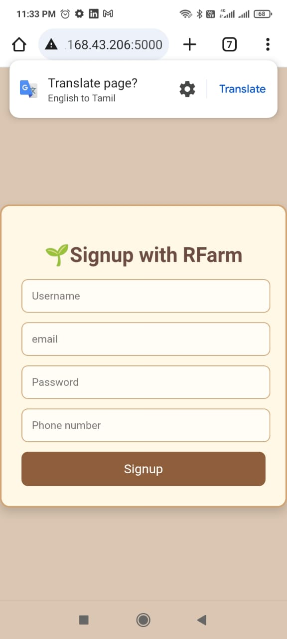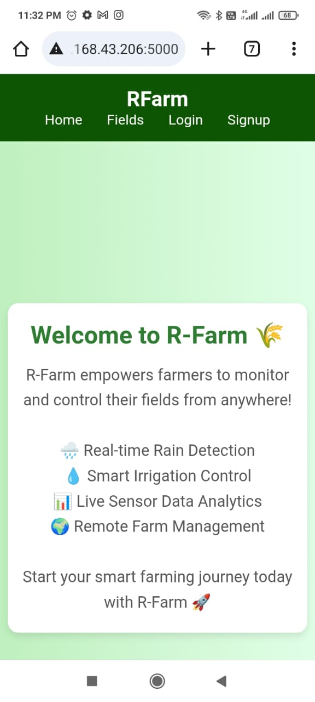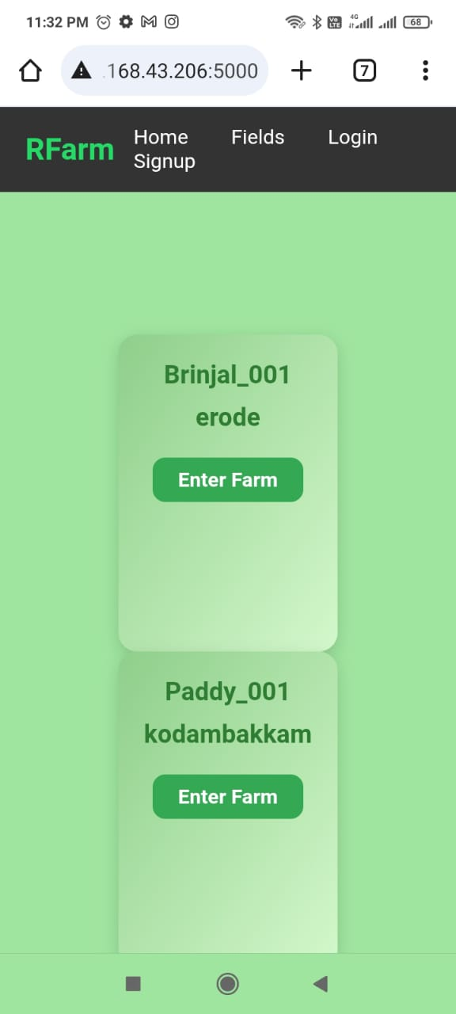

**Fig no.7 – Home page of RFarm site** **Fig no.8 – Signup page of RFarm**

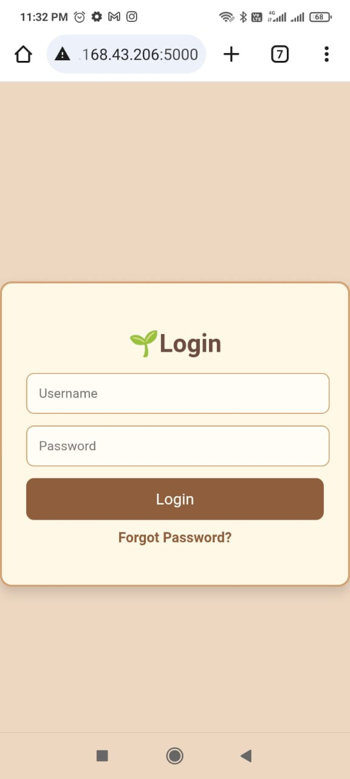

**Fig no. 9 – Login Page of RFarm** **Fig no. 10 – Fields Page of RFarm**

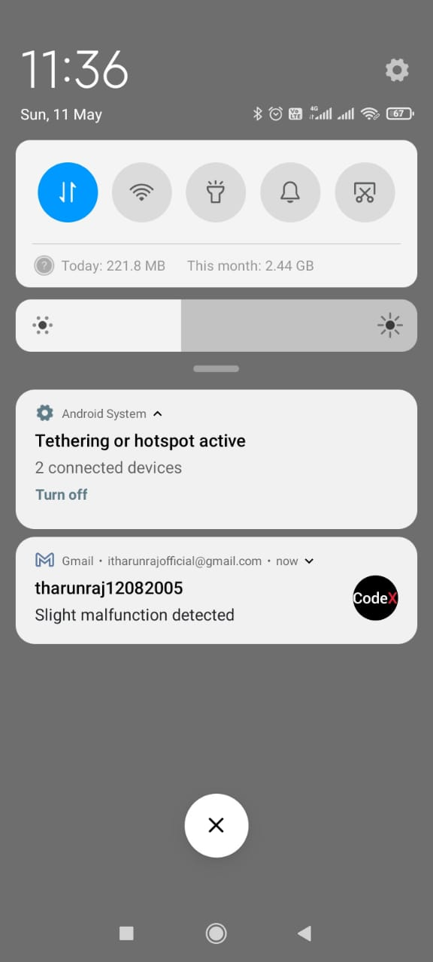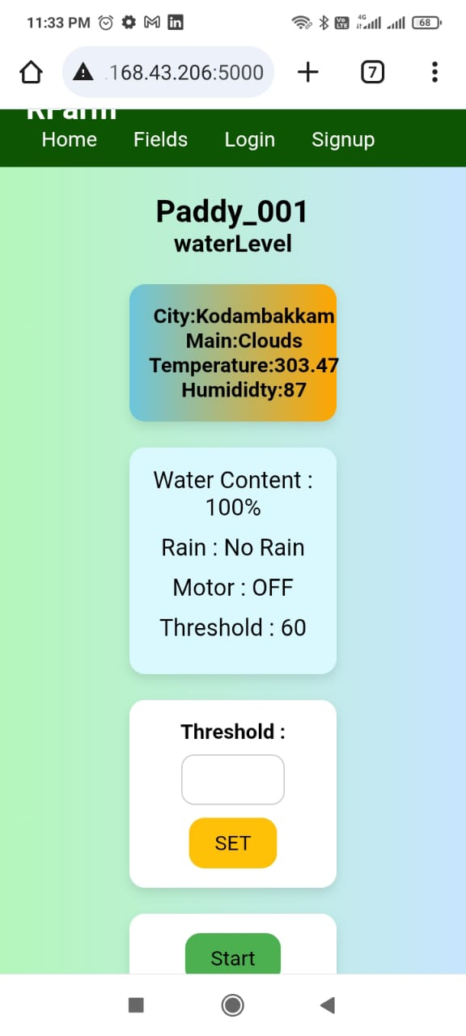

**Fig no.11 – Field Details Page (Mobile view) Fig no.12 – Anomaly detection and mail**

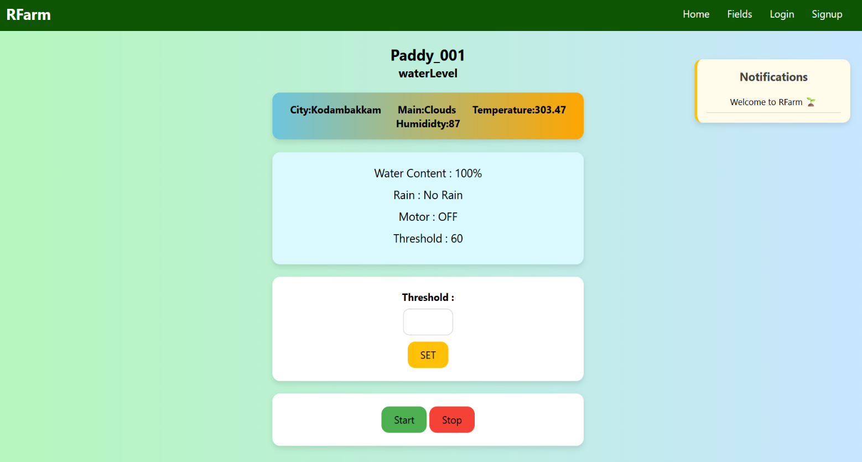

**Fig no.13 – Field details page(Desktop View)**

## Weather API (e.g., OpenWeatherMap)

* + - * Provides weather forecasting to improve irrigation planning.
  1. **Features of the Prototype**

|  |  |
| --- | --- |
| **Feature** | **Description** |
| Soil moisture monitoring | Real-time data shown on dashboard |
| Paddy field water level checking | Displays height of water to assess flooding or drought conditions |
| Rain detection system | Blocks irrigation if rain is occurring or predicted |
| Remote irrigation control | Web interface allows ON/OFF control from any  location |
| Weather forecast integration | Displays 3-day forecast to assist decision-making |
| Multi-field setup  simulation | Enables switching between different field data views |

# **TEST AND FEEDBACK**

The "Agriculture Irrigation System" underwent extensive testing to evaluate the accuracy, performance, and usability of the system. The system was tested both in controlled environments (lab setup) and simulated field conditions to ensure reliability and adaptability across different terrains and crop types. The feedback process involved multiple stakeholders including technical team members, peer reviewers, and potential end-users such as farmers and agricultural consultants.

## Feedback from Team Members

Initial testing was conducted by the internal development team. The objectives were to assess system stability, real-time data collection, and irrigation control logic execution.

## Key Observations:

* + - The ESP8266 microcontroller successfully connected with all sensors and transmitted data reliably over Wi-Fi using HTTP protocols.
    - Moisture sensors responded accurately to dry and wet soil conditions with a latency of less than 2 seconds.
    - The rain sensor provided accurate rainfall detection, which was effectively used to suspend irrigation when rain was detected.
    - Ultrasonic sensors provided consistent water level readings in the paddy field tanks.

## Improvements Suggested:

* + - Include a timeout mechanism in case of network drops to resume data collection once Wi-Fi is restored.
    - Enhance UI responsiveness during data refresh on the web portal.

## Feedback from Peer Reviewers (Other Teams)

Cross-functional peer evaluation was carried out by other design teams to assess UI/UX, system integration, and application logic.

## Observations:

* + - The MERN stack-based web interface was intuitive and visually appealing.
    - Field-specific views allowed easy monitoring of multiple crops.
    - Seasonal crop recommendations and weather integration added practical value.

## Suggestions:

* + - Add notification support (email/SMS) for critical alerts like sensor failure or unusually low water levels.
    - Include a dashboard for admin control and statistics aggregation for comparative analysis.

## Feedback from Users (Farmers and Consultants)

To ensure the system's applicability in real-world farming environments, testing sessions and demonstrations were conducted with farmers and agricultural advisors.

## Participant Profile:

* + - 5 local farmers with experience in paddy and mixed crop farming.
    - 2 agricultural consultants from the Tamil Nadu Agricultural University (TNAU).

## Findings:

* + - Farmers appreciated the system's ability to show real-time data on their mobile phones.
    - The system's ability to disable irrigation during rainfall was highlighted as highly beneficial, reducing manual oversight.
    - Agricultural consultants commended the seasonal crop suggestion module integrated with local climate data.

## Challenges Identified:

* + - Some farmers had difficulty interpreting sensor data due to limited digital literacy.
    - Mobile web interface was slow in areas with low bandwidth.

## Recommended Enhancements:

* + - Include voice prompts or local language translations in the web interface.
    - Develop a lightweight mobile app with offline sync capabilities for rural network conditions.

# **RE-DESIGN AND IMPLEMENTATION**

Based on the comprehensive feedback received during the testing phase, several refinements and enhancements were carried out to improve the performance, usability, and accessibility of the Agriculture Irrigation System. The re-design process focused on aligning the solution more closely with actual user needs— especially for farmers operating in varied climatic and infrastructural conditions.

## Improvements Based on Technical Feedback

The development team implemented several technical changes to ensure higher reliability and efficiency in both sensor data processing and user interface responsiveness.

## Modifications:

* + - **Network Resilience:** Introduced a retry and auto-reconnect mechanism in the ESP8266 firmware to handle Wi-Fi outages gracefully.
    - **Sensor Calibration:** Fine-tuned the analog moisture sensor readings to eliminate discrepancies caused by soil salinity and temperature variations.
    - **Rain Sensor Optimization:** Calibrated debounce logic to prevent false rain detections due to dew or water splashes.

## Implementation Outcome:

* + - Improved system uptime.
    - Accurate and consistent sensor readings across test iterations.
    - Lower packet loss during HTTP data transmission.

## Enhancements from UI/UX Feedback

To address usability concerns, particularly from digitally less-experienced farmers, several improvements were made in the web interface developed using the MERN stack.

## Enhancements:

* + - **Responsive Design:** Optimized the layout for mobile devices with limited screen space.
    - **Local Language Support:** Added Tamil language translation to key UI elements.
    - **Alert System:** Implemented email alerts for low moisture levels and sensor malfunctions.
    - **Graphical Visualizations:** Introduced easy-to-read line graphs and bar charts to visualize daily moisture and rainfall data.

## User Impact:

* + - Enhanced user engagement and comprehension.
    - Increased trust and confidence in the system, even among non-tech-savvy users.

## Feature Additions from End-User Suggestions

End-user feedback was central in shaping additional features that were prioritized in the re-design phase.

## New Features:

* + - **Manual Override:** Provided an emergency on/off switch for irrigation that can be accessed remotely through the web app.
    - **Weather Integration:** Integrated a basic weather API to fetch 3-day forecasts which influence irrigation schedules dynamically.
    - **Offline Mode Preparation:** Initiated development of an offline data caching system for low-bandwidth rural areas (to be released in future iterations).

## Benefits:

* + - Allowed farmers more flexibility in controlling irrigation under unpredictable weather.
    - Reduced water wastage through data-driven and forecast-aware irrigation.
    - Better accessibility in remote villages.

## Hardware Deployment and Implementation Hardware Used:

* + - **Microcontroller:** ESP8266 NodeMCU
    - **Sensors:** Soil moisture sensor (YL-69), Ultrasonic sensor (HC-SR04), Rain sensor (YL-83)
    - **Power Supply:** 12V solar-powered battery system (field-tested)
    - **Connectivity:** Wi-Fi through local hotspots or mobile tethering

## Field Implementation:

* + - Two prototype units were deployed in simulated paddy and vegetable fields within a 5-acre farm.
    - Sensor readings and control logic were remotely monitored through the React web interface.

## System Performance:

* + - Automated irrigation worked as intended based on moisture thresholds.
    - Field feedback confirmed that the automation reduced manual irrigation effort by over 60%.

# **CONCLUSION**

The "Agriculture Irrigation System" project represents a significant step toward transforming traditional irrigation methods into a smart, efficient, and sustainable solution using IoT technology. By combining real-time environmental sensing with remote control capabilities, this system addresses critical challenges in modern

farming, such as resource wastage, manual dependency, and unpredictability in weather patterns.

Through the application of the Design Thinking process, the solution was developed with a user-centric approach, beginning from empathizing with farmers' pain points to defining precise problems, ideating and prototyping solutions, and finally testing and refining the system based on user feedback. The iterative and feedback-driven methodology ensured that the final implementation was not only technically functional but also practically relevant to the target users.

## Key Achievements:

* + - **Remote Monitoring:** Enabled real-time monitoring of moisture, rainfall, and water levels from any location via a responsive web application.
    - **Automated Irrigation:** Deployed threshold-based irrigation control with options for manual override, improving water-use efficiency.
    - **Scalable Architecture:** Designed the system to be adaptable for multiple field locations and different crop types.
    - **Tech Stack Integration:** Successfully utilized ESP8266 microcontrollers and MERN stack technologies for seamless IoT-to-UI connectivity.
    - **User Accessibility:** Focused on user interface simplification, multilingual support, and low-bandwidth compatibility for better rural adoption.

The project not only contributes to the advancement of smart agriculture but also encourages farmers to adopt digital solutions that are accessible, sustainable, and cost-effective. Moreover, the data-driven insights provided by the system have the potential to significantly improve decision-making and boost overall crop yield.

This project exemplifies how technology, when developed with empathy and real- world context, can bridge the gap between innovation and implementation in the agricultural domain.

# **FUTURE WORK**

While the current prototype of the Agriculture Irrigation System has demonstrated promising results in automation, remote monitoring, and user accessibility, several enhancements and expansions are planned to scale its functionality and impact. The future scope of this project focuses on improving technical robustness, expanding features, and increasing adaptability for larger and more diverse farming environments.

## Integration of AI and Data Analytics

Future iterations of the system can incorporate artificial intelligence and machine learning algorithms to predict irrigation schedules and improve decision-making based on historical data.

* + - **Predictive Analytics:** Use time-series data from sensors to forecast soil moisture levels and plan irrigation ahead of time.
    - **Adaptive Scheduling:** AI can analyze past weather patterns and soil response to automate irrigation based on crop-specific needs.
    - **Anomaly Detection:** ML models can detect abnormal sensor behavior (e.g., sudden spikes or drops) and alert users for preventive maintenance.

## Mobile Application Development

To improve accessibility for farmers without laptops or constant internet access, a dedicated Android application will be developed.

* + - **Offline Sync:** Capability to store sensor data locally and upload it once internet connectivity resumes.
    - **Voice-Activated Commands:** Use of voice interfaces in regional languages to make app usage easier for non-tech-savvy farmers.
    - **Push Notifications:** Real-time alerts for irrigation triggers, rain detection, or system malfunctions.

## Extended Sensor Network

Currently, the system supports basic environmental monitoring. In future upgrades, additional sensor modules can be integrated to provide holistic farm insights.

* + - **Temperature and Humidity Sensors:** To correlate crop yield and health with microclimate conditions.
    - **pH and NPK Sensors:** To monitor soil nutrient composition and recommend fertilizers accordingly.
    - **Camera Module (Computer Vision):** For real-time pest or weed detection using AI-powered image analysis.

## Solar-Based Power Optimization

For true field deployment in remote areas with limited power access, optimizing the system for solar-powered operation is crucial.

* + - **Battery Management System (BMS):** Integration of charge controllers for better energy management.
    - **Sleep Modes in ESP8266:** Further optimize power consumption by enabling deep-sleep cycles during sensor inactivity periods.

## Government and Institutional Collaborations

Collaboration with agricultural universities, local panchayats, and government schemes (like PM-KUSUM, Smart Farming Missions) can help pilot the solution on a wider scale.

* + - **Field Trials in Diverse Geographies:** Testing in different climatic zones to adapt the system for universal use.
    - **Subsidized Deployment:** Offer affordable kits for small and marginal farmers.
    - **Training and Awareness:** Conduct workshops on digital farming to encourage technology adoption.

# **LEARNING OUTCOME OF DESIGN THINKING**

The journey of developing the **Agriculture Irrigation System** through the Design Thinking process has been a transformative learning experience for the entire project team. Each phase of the methodology—from empathizing with users to prototyping and testing—taught valuable lessons in problem-solving, collaboration, and innovation. The approach allowed us to shift our focus from a technology-first mindset to a **user-centered design philosophy**, ensuring that the final solution truly addresses real-world needs.

## Key Learnings from Each Stage Empathize Stage

* + - Gained deep insights into the challenges faced by farmers, especially those

managing multiple fields in different locations.

* + - Understood the need for simplification and accessibility in technological solutions for rural users.
    - Developed empathy through user interviews, case studies, and observing existing irrigation practices.

## Define Stage

* + - Learned to translate vague pain points into clear and actionable problem statements.
    - Realized the importance of scoping the problem effectively to ensure the solution is both feasible and impactful.
    - Understood how to prioritize user needs over technical complexity.

## Ideate Stage

* + - Fostered creative thinking and encouraged the generation of diverse solution ideas without judgment.
    - Developed mind maps and value propositions that focused on water conservation, ease of use, and remote access.
    - Improved skills in collaborative brainstorming and evaluating ideas based on impact and feasibility.

## Prototype Stage

* + - Understood how to build fast, functional prototypes using available resources (ESP8266, sensors, MERN stack).
    - Learned the importance of rapid iteration, modular development, and real- world simulation testing.
    - Focused on solving "just enough" of the problem to test the concept effectively.

## Test and Feedback Stage

* + - Gained appreciation for feedback from users, peers, and stakeholders.
    - Discovered practical usability issues that were not visible during development.
    - Learned to accept criticism constructively and improve the product through iterative refinement.

## Re-design and Implementation Stage

* + - Realized that successful design is not just about innovation, but about evolution through feedback.
    - Integrated multiple viewpoints to redesign a more holistic and practical system.
    - Enhanced our ability to balance technical and user-centric constraints.

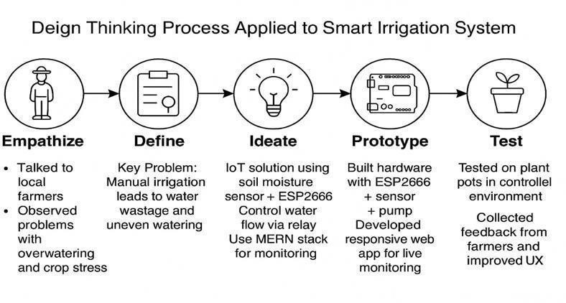

**Fig no. 14- Application of Design Thinking Process in RFarm**

## Broader Impact and Growth

* + - Strengthened **interdisciplinary collaboration** between software, electronics, agriculture, and design thinking domains.
    - Developed **project management skills**, including task allocation, milestone tracking, and documentation.
    - Enhanced **communication skills** through regular presentations, demo sessions, and report writing.
    - Fostered a **problem-solving mindset** that values observation, iteration, and human-centered solutions.

# **13. REFERENCES**

## Journal Papers

1. K. S. Rao and D. S. Kumar, “IoT-Based Smart Irrigation System Using NodeMCU,” *International Journal of Engineering and Advanced Technology (IJEAT)*, vol. 9, no. 3, pp. 456–460, Feb. 2020.
2. P. R. Sinha and M. K. Sinha, “Smart Irrigation System Using IoT,” *International Research Journal of Engineering and Technology (IRJET)*, vol. 7, no. 6, pp. 3120–3125, Jun. 2020.
3. S. Patil, R. Kulkarni, and A. Jadhav, “An IoT-based Automated Irrigation System using Soil Moisture Sensor and ESP8266,” *International Journal of Innovative Research in Computer and Communication Engineering (IJIRCCE)*, vol. 8, no. 4, pp. 900–905, Apr. 2020.
4. Z. Sun and J. Liu, “A Design Thinking Process Model for Capturing and Formalizing Design Intents,” *2008 International Symposium on Computational Intelligence and Design*, Wuhan, China, 2008, pp. 330–333, doi: 10.1109/ISCID.2008.192.

## Websites

1. “ESP8266 Overview,” *Espressif Systems*, [Online]. Available: https://[www.espressif.com/en/products/socs/esp8266](http://www.espressif.com/en/products/socs/esp8266)
2. “Design Thinking – Stanford d.school,” *Hasso Plattner Institute of Design*, [Online]. Available: <https://dschool.stanford.edu/>
3. “MERN Stack Overview,” *MongoDB Developer Hub*, [Online]. Available: <https://www.mongodb.com/mern-stack>